NAGVA Board Call
Minutes: 01/24/2018

- Roll Call – Mark E, Drew C, Jimmy S, Brian S, Jason F, Rich S, Lew S, Brian D, Scott K, Eric N, Jason P
- Officer/Department Reports
  - President
  - Vice President
  - Secretary
    - Amendments are due by February 25th
    - Spirit Award nominations due by April 1st
    - Hall of Fame nominations due by April 1st
    - Executive Board elections – letter of intent due by April 25th
  - Treasurer
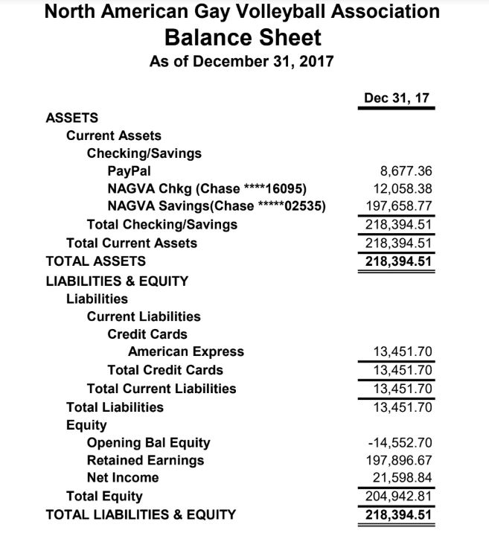
  - Tournaments
  - Officials
  - Communications
    - Still trying to get better formatting for Instagram
    - Too many facebook post appears to throttle it’s appearance in news feeds
  - Canadian Representative
    - Met with Toronto and Montreal, waiting for a date
- MAL Reports
  - Trevor
  - Rich
    - Hawaii – tournament went very well. Plans to continue it.
  - Brian
    - Working with Jen in Regions and helping other Midwest tournaments push higher A divisions
  - Jimmy
- Championships Update
  - Board Hotel Rooms
  - Board Meeting – Wednesday, May 23rd
  - NAGVA Serves – Thursday, May 24th
  - A/AA Open Division – pimping out division
  - Fundraising - $3500 so far, Tim M will be running a one day tourney, beer busts, reached out to the local bars for sponsorship
- New Business
  - Ken Mau Appeal – one year strong enough to deter this from happening. Appeal denied 7-0-1
  - Robbie Casarez Appeal – discussion was had – he said, she said – no way to tell who was telling the truth, Q: Had he played before with this team? A: Does not appear so. The captain was new. Q: Do we have enough evidence? How did Robbie find the team? How many people of the team? 5-3 appeal granted
  - Women’s Division
    - Problems with Women’s division
      - Issues – poor attendance
      - Nothing that says you can’t offer it, already in the bylaws and part of the sanctioning packet
  - Spanish language help email address: ayuda@nagva.org
- Meeting Adjourns

